**Ideation Phase**

**Empathize & Discover**

|  |  |
| --- | --- |
| Date | 15 April 2025 |
| Team ID | SWTID1743947156 |
| Project Name | FullStack-Expense-Tracker |
| Maximum Marks | 4 Marks |

**Empathy Map Canvas:**

An empathy map is a simple, easy-to-digest visual that captures knowledge about a user’s behaviours and attitudes.

It is a useful tool to helps teams better understand their users.

Creating an effective solution requires understanding the true problem and the person who is experiencing it. The exercise of creating the map helps participants consider things from the user’s perspective along with his or her goals and challenges.

**Example:**

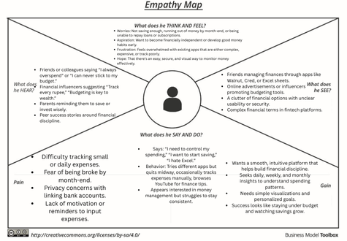

**What does the user SEE?**

* **Friends managing finances through apps like Walnut, Cred, or Excel sheets.**
* **Online advertisements or influencers promoting budgeting tools.**
* **A clutter of financial options with unclear usability or security.**
* **Complex financial terms in fintech platforms.**

**What does the user HEAR?**

* **Friends or colleagues saying “I always overspend” or “I can never stick to my budget.”**
* **Financial influencers suggesting “Track every rupee,” “Budgeting is key to wealth.”**
* **Parents reminding them to save or invest wisely.**
* **Peer success stories around financial discipline.**

**What does the user THINK and FEEL?**

* **Worries: Not saving enough, running out of money by month-end, or being unable to repay loans or subscriptions.**
* **Aspiration: Want to become financially independent or develop good money habits early.**
* **Frustration: Feels overwhelmed with existing apps that are either complex, expensive, or track poorly.**
* **Hope: That there's an easy, secure, and visual way to monitor money effectively.**

**What does the user SAY and DO?**

* **Says: “I need to control my spending,” “I want to start saving,” “I hate Excel.”**
* **Behavior: Tries different apps but quits midway, occasionally tracks expenses manually, browses YouTube for finance tips.**
* **Appears interested in money management but struggles to stay consistent.**

**PAIN**

* **Difficulty tracking small or daily expenses.**
* **Fear of being broke by month-end.**
* **Privacy concerns with linking bank accounts.**
* **Lack of motivation or reminders to input expenses.**

**GAIN**

* **Wants a smooth, intuitive platform that helps build financial discipline.**
* **Seeks daily, weekly, and monthly insights to understand spending patterns.**
* **Needs simple visualizations and personalized goals.**
* **Success looks like staying under budget and watching savings grow.**